Parent Letter Sample 8/14
<date>

Dear Parents of _________,
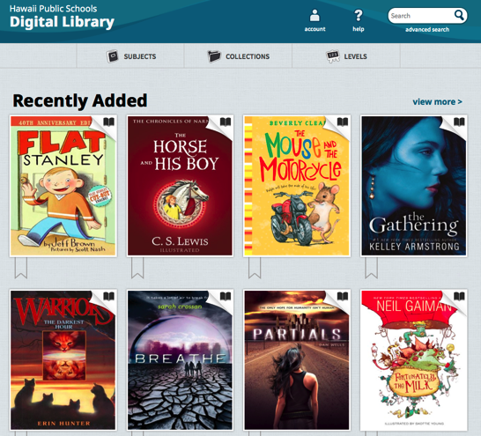
School Name is committed to bringing unique learning opportunities to our students and we are pleased to introduce you to the HIDOE Digital Library! This new, free reading service for students at School Name provides digital books that can be accessed 24/7 at http://hidoe.lib.overdrive.com.
Why a Digital Library?
The HIDOE Digital Library is using the OverDrive platform, similar to the one used at the Hawaii State Public Library. The collection is an extension of our physical library, only it’s online with 24/7 access to eBooks and audiobooks. It’s convenient for students to check out titles anytime, anywhere with no worry about misplacing a book or running up late fees – these digital titles automatically return at the end of the lending period!
The HIDOE Digital Library on Overdrive can help students of all ages read more and improve comprehension. Struggling or reluctant readers, learning-challenged, second language learners, and gifted readers can all benefit from this service.
- Enrich vocabulary and improve comprehension and pronunciation
- Introduce students to books above their reading level
- Teach critical listening
- Help busy kids find time to read
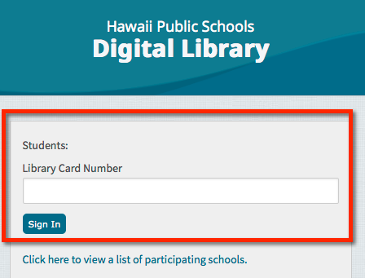
How do I access the Digital Library?
To access the HIDOE Digital Library, students need to complete the following steps:
1. Browse the secure website at http://hidoe.lib.overdrive.com on a computer, tablet, smartphone or eReader device.
2. Login with their Library Card Number (This is their 10-digit student ID number)
3. Download and borrow any of the available ebooks or audiobooks to their device.

Where can I find more information?
[Contact information if applicable] or visit http://vlibrary.freshdesk.com.
 |  | * * * cut out card below for easy reference * * *
Sincerely,  School Library Media Specialist/Principal/Staff Coordinator  Signature block |  | HIDOE Digital Library Card – SY 15-16  <School Name>  http://hidoe.lib.overdrive.com  Student Name: <merge student name>  Library Card Number: <merge student ID number>

