How to access your Overdrive MARC records
and upload them to LS2

To access MARC on the Overdrive FTP site:  1. Log in to http://ftp.overdrive.com with your credentials and choose “Web Client.” If you need help to retrieve your credentials, email our Account Specialist Beau Livengood at blivengood@overdrive.com. | 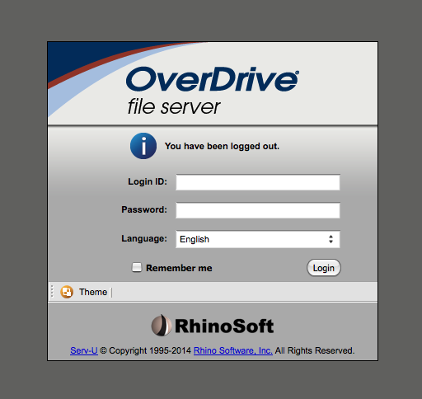
Find and highlight the MARC file to be imported.  Right click on the file and select Download. | 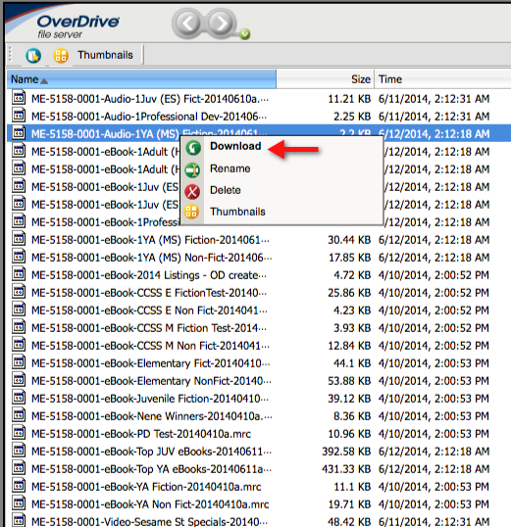
If you’re using the Chrome browser, you may find the “Download” at the bottom of the screen. | 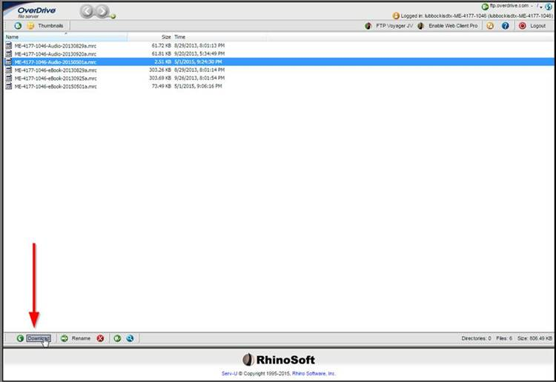
The system should default to Save File.  Depending on the browser you use, the prompt may say “Save as” or similar; choose the option that allows you to save the file to your computer. | 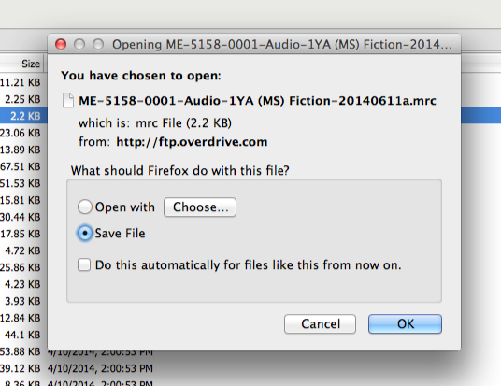
Save the MARC file to your desktop. | 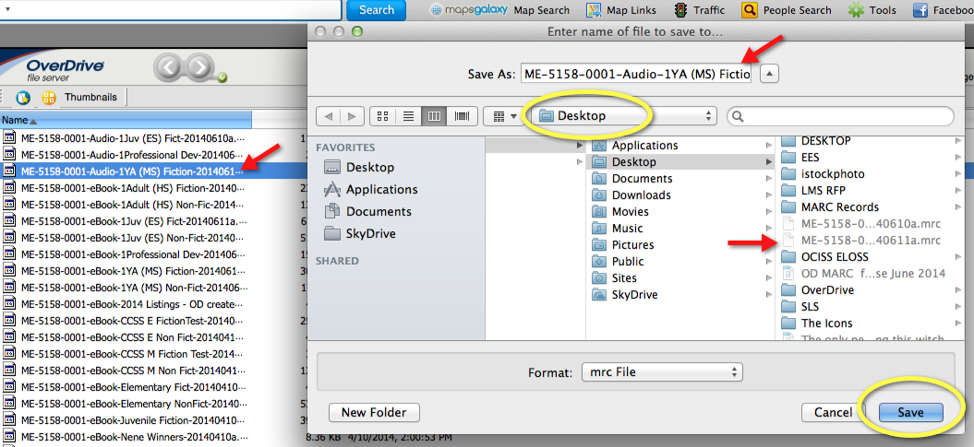
Log in to LS2 Backroom using your 3-digit school code+admin  (_ _ _admin) and your password. | 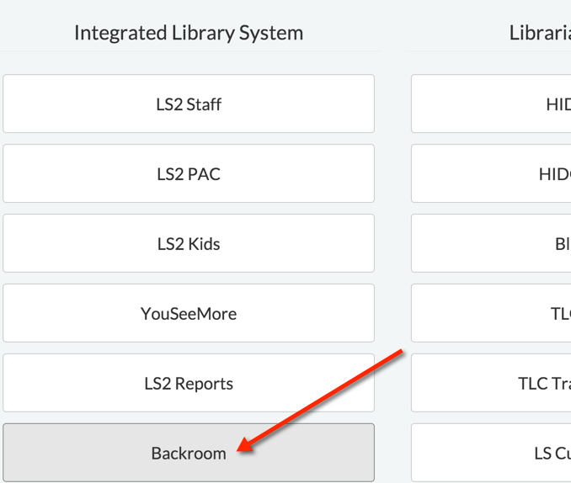
Click on Start an Import | 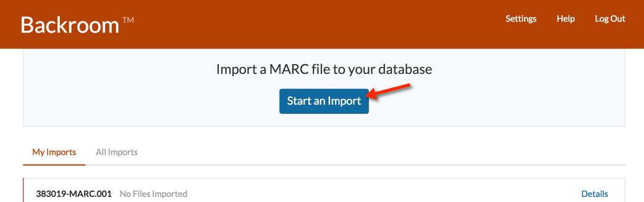
Click on choose a File. | 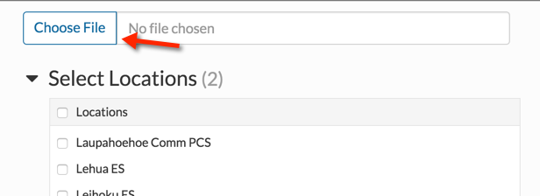
Locate the MARC file on your desktop. Select it; click on Open at the bottom of the screen. Your file name will appear. | 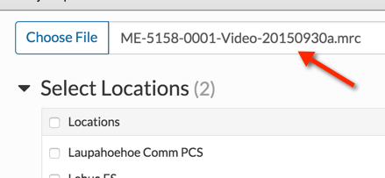
Select Locations:  The system will default to your school name, based on your login.  Please always check to make sure only your school is selected. | 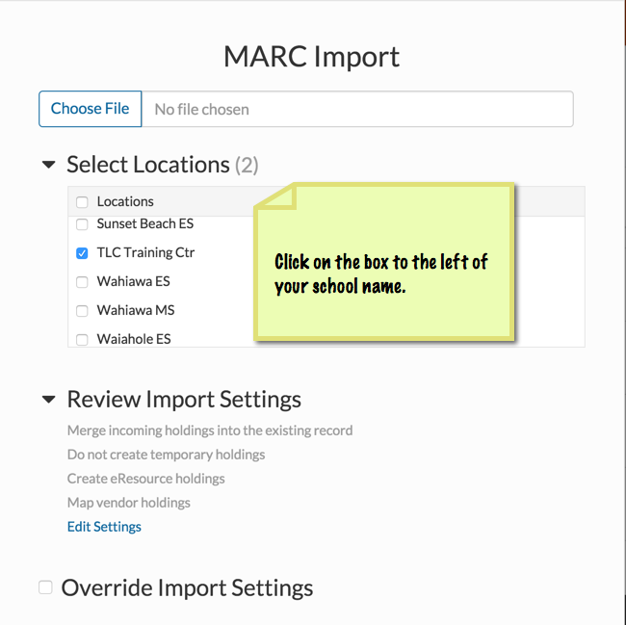
Scroll to the bottom and click on Import File | 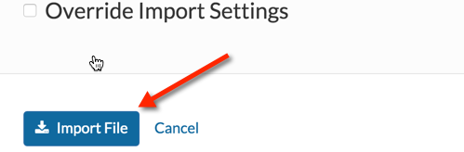
You will receive an Import Pending confirmation of receipt.  Note, if errors occur during the import process, download the file and the error report and submit them to TLC via a ticket for review. | 